Драга децо,
Подсећамо вас да пратите наставу на РТС-у.Данас ћемо научити како да дамо савете или како даговоримо о правилима, oбавезама, забранама… Читајте пажљиво неколико пута, иможете да запишите у свескама или сачувате на рачунару.
I can make rules and give advice
(Must, mustn’t, should, shouldn’t )
Правила MUST – МОРАТИ MUSTN’T - СТРОГА ЗАБРАНА / НЕ СМЕТИ
Савети SHOULD – ТРЕБАЛО БИ SHOULDN’T - НЕ БИ ТРЕБАЛО
Срешћете речи Obligation – обавеза Advice - савет

Examples Примери
I must do my homework. - Youshould start now.
You mustn’t be late for class. You shouldn’t go so slowly.
We must wash our hands.We should do this now.

Remember! Запамтите!
We can use ‘must’ to talk about rules and strong obligationWe use “should” to talk about advice
For the negative, we say ‘must not’ or ‘mustn’t’. For the negative, we say “should not’ or “shouldn’t’.
Parents must take care of their children. They should play games with their children
You mustn’t shout in the library. You shouldn’t speak there.
She must not forget her books. You should give her now.

Be careful!
The main verb is without ‘to’.
He must be careful when cutting food.
I mustn’t make a mess.
You shouldn’t wear shorts. You should take a jacket

We say... We don’t say...
You must look both ways when crossing the road. (NOTYou must to look both ways when crossing the road.)
Children must respect their parents. (NOT Children must respecting their parents.)
You should listen to your parents (NOT you should to listen to your parents)
ВАЖНО!Можете да препишите или направите белешке
Ако ово разумете, веома лако ћете урадити вежбања 3. И 4. на страни 63 у вашим књигама.
Вежбу 5 на страни 63 урадите у свесци.

А сада да објаснимо и HAVE TO (морати)слично као и MUST (морати), but let’s see
Must and have to are both used for obligation and are often quite similar. They are both followed by the infinitive.
I must go now. / I have to go now.

Are these exactly the same?(Али да ли се користе баш у истим ситуацијама ?)
Opinion - мишљење
Well, almost. We often use must for more personal opinions about what it is necessary to do, and have to for what somebody in authority has said it is necessary to do.

I must remember to get a present for Daisy. (my opinion)
You have to look after their hair regularly. (dog experts say so)
Do you have to wear a tie for school? (asking about school rules)

Which verb do people use more? (Шта се користи чешће?)
Have to is more frequent in conversation; must is used more in formal writing, for example in written notices.
Passengers must fasten their seat-belts.

Do they change in form for I, you, he, she, etc.? Да ли се MUST иHAVE мењају у трећем лицу?
Have changes in the third person singular (he/she/it has); I have to / He has to/ she has to
but must doesn’t change. It’s a modal verb and modals don’t change. I must / He must

ОВО ЈЕ ВЕОМА ВАЖНО!
MUSTAN’T и DON’T HAVE TO имају потпуно различито значење
The positive forms are very similar in meaning, but the negative forms are completely different. Значење потврдног облика је веома сличано, али су ОДРИЧНИ облици ПОТПУНО РАЗЛИЧИТИ у значењу.
You mustn’t forget ...
(don’t forget - you have no choice – не смеш да заборавиш- немаш избора)
If you don't like him, you don't have to see him again. Ако ти се не свиђа, не мораш да га видиш поново.
(Тhere is no obligation to see him again, but you have a choice/ непостојиобавезадагавидишпоново, алисвакакоимашизбор.

Umm, I’m still a bit confused ... Ух, ово мало збуњује
Here's an example you can remember – Ево примера који ћеш запамтити:
In a non-smoking area you mustn’t smoke, but in a smoking area you don’t have to smoke but you can if you want to.
У непушачком делу не смеш да се запалиш цигарету, у пушачком делу не мораш да запалиш цигарету, али можеш ако желиш.
Ah! Right, I mustn’t forget that. И наравно, увек бирајте непушачки део!

Ево и вежбања
Write four rules and protect yourself from covid-19
1.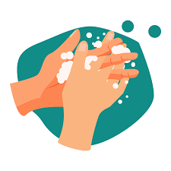 2. 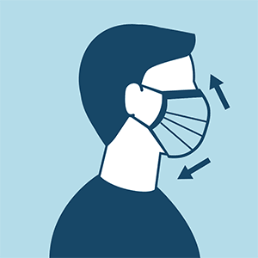 3.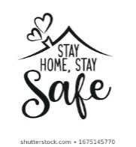 4.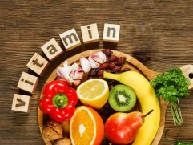

ДОМАЋИ ЗАДАТАК
Као што стоји на првој страни, урадитевежбања 3. И 4. на страни 63 у вашим књигама.
Вежбу 5 радите у свескама.
Наставницама сликате вежбу 5. Страна 63 у вашим књигам коју сте урадили у свескама и
4 правила понашања која сте написали на основу сличица које су вам дате изнад.
Пошаљете до следећег четвртка.
Ево и додатног вежбањаако неко нема књигу или жели да провежба мало више. Ова додатна вежбања нису обавезна.
На последњој страни се налазе решења како би на крају проверили. Уколико се деси да вам нешто није јасно обавезно се јавите наставницамам и проверите.
Поздрав од ваших наставница!!!!

1.Check your grammar: grouping – have to, must and should Put the phrases in the correct groups.
Разврстај реченице дате у табели

Drink cold water if you have a cold | complete a lot of exams, study and training to be a doctor | rest and drink lots of liquids if you have a cold
arrive at the airport earlier. | always get enough sleep | show your passport or identity card to get on a plane.
be seventeen to drive a car in the UK | use your mobile phone during an exam | drive on the right side of the road in the UK – everyone drives on the left!

You have to… | You mustn’t… | You should…

2. Correct the mistakes and write these sentences on the line below.Исправи грешке у датим реченицама
1. You must to see the Chrysler Building when you're in New York.
………………………………………………………………………………………………….
2. Do I should call him?
………………………………………………………………………………………………….
3. We don't must make any noise; my grandfather's sleeping.
………………………………………………………………………………………………….
4. You really should to go and see a doctor about that.
………………………………………………………………………………………………….
5. He doesn't should talk to people like that.
………………………………………………………………………………………………….
6. Why we always have to come to the same café?
………………………………………………………………………………………………….
7. Must you to make that terrible noise all the time?

Решења за проверу
- Вежба
You have to… | You mustn’t… | You should…
show your passport or identity  card to get on a plane. | use your mobile phone during an exam. | arrive at the airport earlier.
be seventeen to drive a car in the UK. | drive on the right side of the road in the UK – everyone drives on the left! | always get enough sleep
complete a lot of exams, study  and training to be a doctor. | Drink cold water if you have a cold. | rest and drink lots of liquids if you  have a cold.

- Вежба
1. You must see the Chrysler Building when you're in New York.
1.You should see the Chrysler Building when you're in New York.

2. Should I call him?

3. We mustn't make any noise; my grandfather's sleeping. Или
We must not make any noise; my grandfather's sleeping.

4. You really should go and see a doctor about that.

5. He shouldn't talk to people like that. Или
He should not talk to people like that.

6. Why do we always have to come to the same café?

7. Must you make that terrible noise all the time?

