Test
Ime i prezime____________________________________________
- Zaokruzi tačan odgovor: (4p)
- What is he doing?
- He is watch TV.
- He watches TV.
- He is watching TV.

- I _______ playing computer games.
- Is
- am
- are

- They ________ doing their homework.
- aren't
- don't
- isn't

- My sister always ___________ at seven o'clock in the morning.
- get up
- gets up
- is getting up

- Spoji početak rečenice iz prve kolone sa odgovarajućim nastavkom rečenice iz druge kolone (upiši slovo u kvadratić): (5p)

Look! My friends a) is talking.

This test b) plays football after school.

John always c) is long.

Be quiet! The teacher d) are dancing.

Mary usually e) doesn't play with her sisters.

- Zaokruži tačan odgovor na osnovu slike (5p):
He is wearing_______________
- a brown jacket, yellow trousers, red trainers and a blue T-shirt.
- a brown jacket, blue T-shirt, white trainers and blue trousers
- a brown jacket, a blue T-shirt, white trainers and red trousers.

What is she doing?
- She is riding a bike.
- She is reading a book.
- She is writing a book.

What is he doing?
- He is brushing his hair.
- He is washing his hands.
- He is taking photos.

What are they doing?
- They are doing their homework.
- They is doing their homework.
- They do their homework.

What does your grandma do every Saturday? 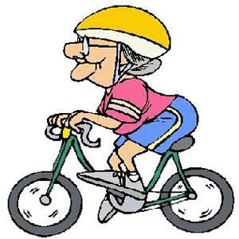
- She ride a bike.
- She rides a bike.
- She is riding a bike.

- Zaokruži slovo ispred tačnog odgovora ( kod svakog slova imaš ponuđena dva glagola, prvi ide na prvu prazninu, a drugi na drugu) (6p):

- I usually __________ jeans, but now I _________________a dress.
- wear / am wearing
- wears / wearing
- am wearing / wear

- Peter ____________ in his garden every afternoon, but now he _______________in the house.
a)plays /is playing
b) playing/plays
c) play / is playing

- They usually _________ to school by bus, but now they _____________ to school.
- Go/walk
- Going/walking
- Go/are walking

- Zaokruži slovo ispred tačnog odgovora: (3p)
- Kako bi na engleskom rekli pola tri (2:30)
- Half past three.
- Half past two.
- Half past four.

- Kako bi na engleskom rekli 5 i 15?
- Quarter past five.
- Quarter past four.
- Quarter to five.

- Kako bi na engleskom rekli 15 min do 8 (7:45)
- Quarter to eight.
- Quarter past eight.
- Quarter to seven.

