Predmet: engleski jezik Razred: četvrti
deseta nedelja 18-23.5.2020.
Nastava na daljinu – materijal za rad

Draga deco, ove nedelje imamo malo više da radimo. Radimo prošlo vreme glagola biti I nepravilnu množinu imenica. Nadam se da neće da vam bude preteško I da ćete razumeti ovo što učimo. Molim vas da dobro pročitate sve, prepišite ono što mislite da je bitno I da će da vam pomogne da razumete I naučite sve ovo. Pratite čas na televiziji, pročitajte lekciju u udžbeniku na strani 94. I na strani 100. Tu imate primere za ovo što učimo.
https://youtu.be/vcB4Xa1Wxrc - Unit 14
https://youtu.be/Cp8RRtnl1o8 - Unit 15
- Prvo radimo prošlo vreme glagola BITI (TO BE). U sadašnjem vremenu imamo tri oblika ovog glagola i vi ih već znate (Prepišite u sveske ono što mislite da vam je bitno):
AM
IS
ARE
Za prošlo vreme imamo dva oblika
WAS
WERE
Koristimo ih ovako:
I WAS – ja sam bio/bila WE WERE – mi smo bili/bile
YOU WERE – ti si bio/bila YOU WERE – vi ste bili/bile
HE WAS – on je bio THEY WERE – oni su bili/one su bile
SHE WAS – ona je bila
IT WAS – ono je bilo
Odrični oblik:
I WASN'T – ja nisam bio/bila WE WEREN'T – mi nismo bili/bile
YOU WEREN'T – ti nisi bio/bila YOU WEREN'T – vi niste bili/bile
HE WASN'T – on nije bio THEY WEREN'T – oni nisu bili/one nisu bile
SHE WASN'T – ona nije bila WAS NOT=WASN'T
IT WASN'T – ono nije bilo WERE NOT = WEREN'T
Upitna rečenica:
WAS I? – da li sam ja bio/bila? WERE WE? – da li smo mi bili/bile?
WERE YOU? – da li si ti bio/bila? WERE YOU? – da li ste vi bili/bile?
WAS HE? – da li je on bio? WERE THEY? – da su oni bili/one bile?
WAS SHE? – da li je ona bila?
WAS IT? – da li je ono bilo?
https://youtu.be/Yn9e2pDhMfM - ovde možete da čujete kako se sve ovo izgovara
Na pitanja možemo da odgovorima na dva načina:
Were you in the park yesterday? - Yes, I was. Ili No, I wasn't.
Was she your friend? – Yes, she was. Ili No, she wasn't.
Were they scared? – Yes, they were- ili – No, they weren't.
Reči koje nam pomažu da odredimo da li se nešto dešava u prošlosti, tj. Priloške odredbe za vreme su
Yesterday – juče
Last week – prošle nedelje
Last month- prošlog meseca
Last year – prošle godine
5 minutes ago – pre pet minuta
8 days ago- pre 8 dana
Ili bilo koja druga reč ili izraz koja nam pomaže da shvatimo da se radnja desila u prošlosti
Primeri:
I am happy today – I was sad yesterday.
She is at home now. – She was in Belgrade last week.
It is sunny, we are in the park. – Yesterday, it was rainy, we were inside all day.
The pupils were at school three months ago.
Were you shorter than your brother last year?
I wasn't shorter, I was taller than my brother.
They weren't hungry, they were thirsty.
Was she at school yesterday?

Uradite u svesci sledeće primere. Stavite was/were/wasn't ili weren't gde treba. Recenice koje imaju u zagradi (not) su u odričnom obliku.
- She _________ on a picnic last weekend.
- We __________ tired yesterday.
- My pencil _________ on this desk yesterday.
- Paul and John __________ (not) at school last week.
- _________ you at the Zoo last year?
- My aunt _________ in London last month.
- I __________ really happy for my birthday!
- They __________ at a party last night.
- He ____________ naughty when he _________ little.
- The babies ___________(not) cold, they ____________ hungry.
- There _________ a spider in my room, five minutes ago!
- __________ he scared of snakes?
Ovde imate različite linkove gde možete da čujete malo više o ovom glagolu u prošlom vremenu
https://youtu.be/KAsacxmPh1Q
https://youtu.be/w48Oi7P465c
https://youtu.be/RWTZ5-ICKk4
https://youtu.be/pS6MubcSf_g
https://youtu.be/59srW_OQ6qQ
2. Sledeća stvar koju ćemo danas učiti je nepravilna množina. Do sad smo učili da kad hoćemo da stavimo neku reč u množinu toj reči dodajemo nastavak – s.
An apple – apples a dog – dogs a pencil – pencils a cow – cows a sandwich – sandwiches
U engleskom jeziku postoje neke reči kod kojih ne možemo da pravimo množinu tako što dodajemo nastavk –s, nego koristimo druge reči da bismo rekli da ima više nečega. Vi neke od ovih reči znate, a neke ćemo sad da naučimo. (Ne morate da crtate slike ali napišite ove reči u svesci i napišite šta one znače)
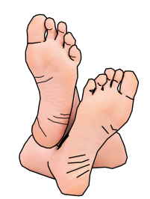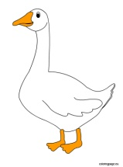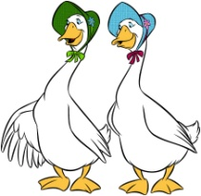
One foot two feet one tooth teeth a goose two geese
a child – dete children – deca a man men
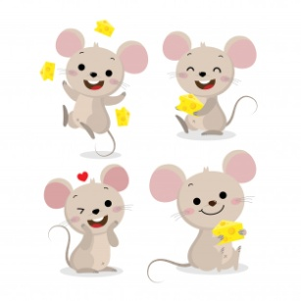
a woman women a mouse mice
Neke reči imaju isti oblik i za jedninu i za množinu:
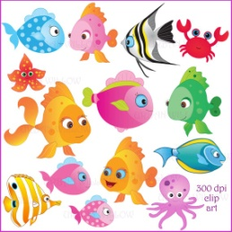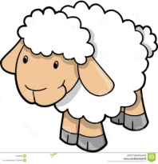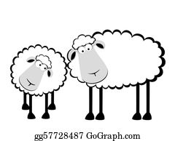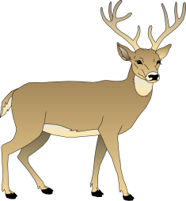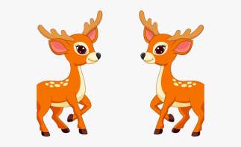
A fish fish a sheep sheep a deer deer
Molim vas da pogledate i poslušate klipove na ovim linkovim jer tu možete da čujete kako se ove reči izgovaraju:
https://youtu.be/oc3DGlnQYNE
https://youtu.be/LwkM2iTudSg
https://youtu.be/gc7ss2e6mB4
https://youtu.be/7uvqBPDzaQo
https://youtu.be/BD26It1aL6w
Hajde sad da probamo da uradimo vezbanja sa ovim rečima:
- There weren't many _____________ in the park, there was just one child.
- I brush my ___________ every morning.
- Cats like to chase ____________. 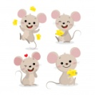
- My brother has got big _____________.
- There were three ____________ in the street.
- Those _____________ are my mum's friends.
- There are many ______________ in that river. 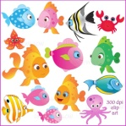
- My grandma has many _____________.
Za one koji hoće još da vežbaju, na ovim linkovima imate korisna vežbanja:
Za prošlo vreme glagola TO BE:
https://www.liveworksheets.com/worksheets/en/English_as_a_Second_Language_(ESL)/Verb_to_be/Am_-_Is_-_Are-_Was_-_Were_jq21324vn
https://www.liveworksheets.com/worksheets/en/English_as_a_Second_Language_(ESL)/Was_or_were/Was_or_were$_yr18112if
https://www.liveworksheets.com/worksheets/en/English_as_a_Second_Language_(ESL)/Past_simple/Was_or_were_iv53769vo
Za nepravilnu množinu:
https://www.liveworksheets.com/worksheets/en/English_as_a_Second_Language_(ESL)/Irregular_plurals/Singular_and_Plural_xy117394fu
https://www.liveworksheets.com/def_files/2017/10/25/710251357537195/thumb710251357537195.jpg
Za domaći: Uradite dva vežbanja koja imate ovde i uradite vežbanja u radnoj svesci na 94. I 101. Strani. Pošaljite svojoj nastavnici do subote u 14h. Molim vas da poštujete rok i vreme određeno za slanje. Ukoliko vam nešto nije jasno, pitajte svoju nastavnicu da vam objasni.
Vaše nastavnice: Julija Petrović, Valentina Nikolić, Ivana Miletić, Jelena Krstić, Dragana Ristić, Tanja Nikolić I Marijana Živulović

